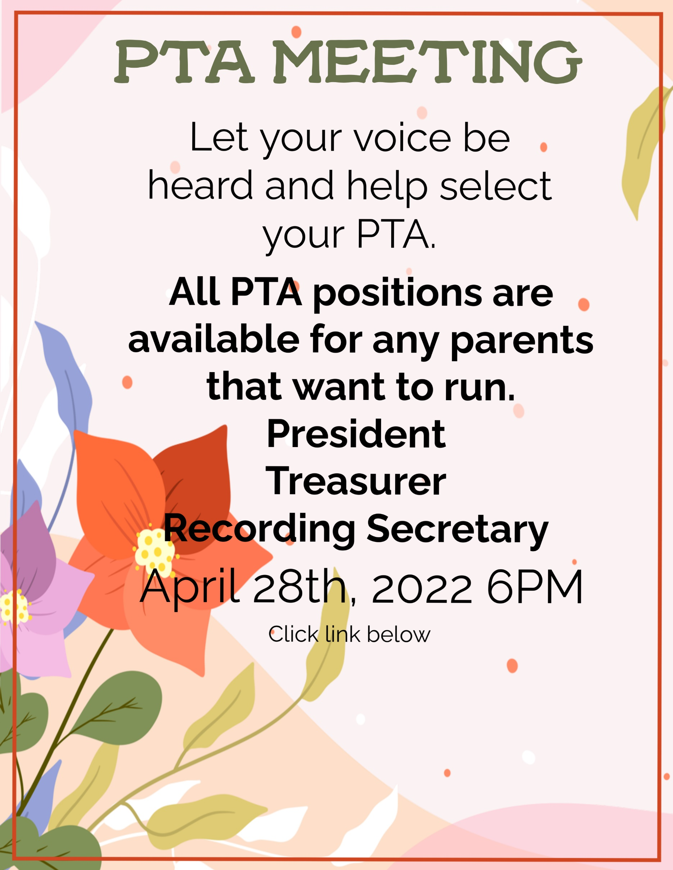
https://nycdoe.zoom.us/j/88134679265?pwd=L3BRVHBIajNHK3RicTlwd2hvQkZ6dz09
Meeting ID: 881 3467 9265
Passcode: 677650
One tap mobile
929-205-6099
Meeting ID: 88134679265
Passcode: 677650

